
Story

Date | 31 October 2026
Team ID | Not applicable – Individual Project
Project Name | EV Market Performance & Insights
Maximum Marks | 5 Marks

By using stories in Tableau, you can effectively communicate complex data in a way that is both interactive and engaging, making it easier for the audience to follow along and understand the insights. It’s a tool for data storytelling, allowing you to present insights in a cohesive, engaging way that takes viewers through a logical progression of findings or analyses.
In Tableau, Story is a feature that allows you to create a sequence of dashboards, visualizations, and text to present data insights in a cohesive and narrative-driven way. It's like a slideshow within Tableau that guides the audience through a series of data points, helping them understand key insights, trends, or outcomes of your analysis.

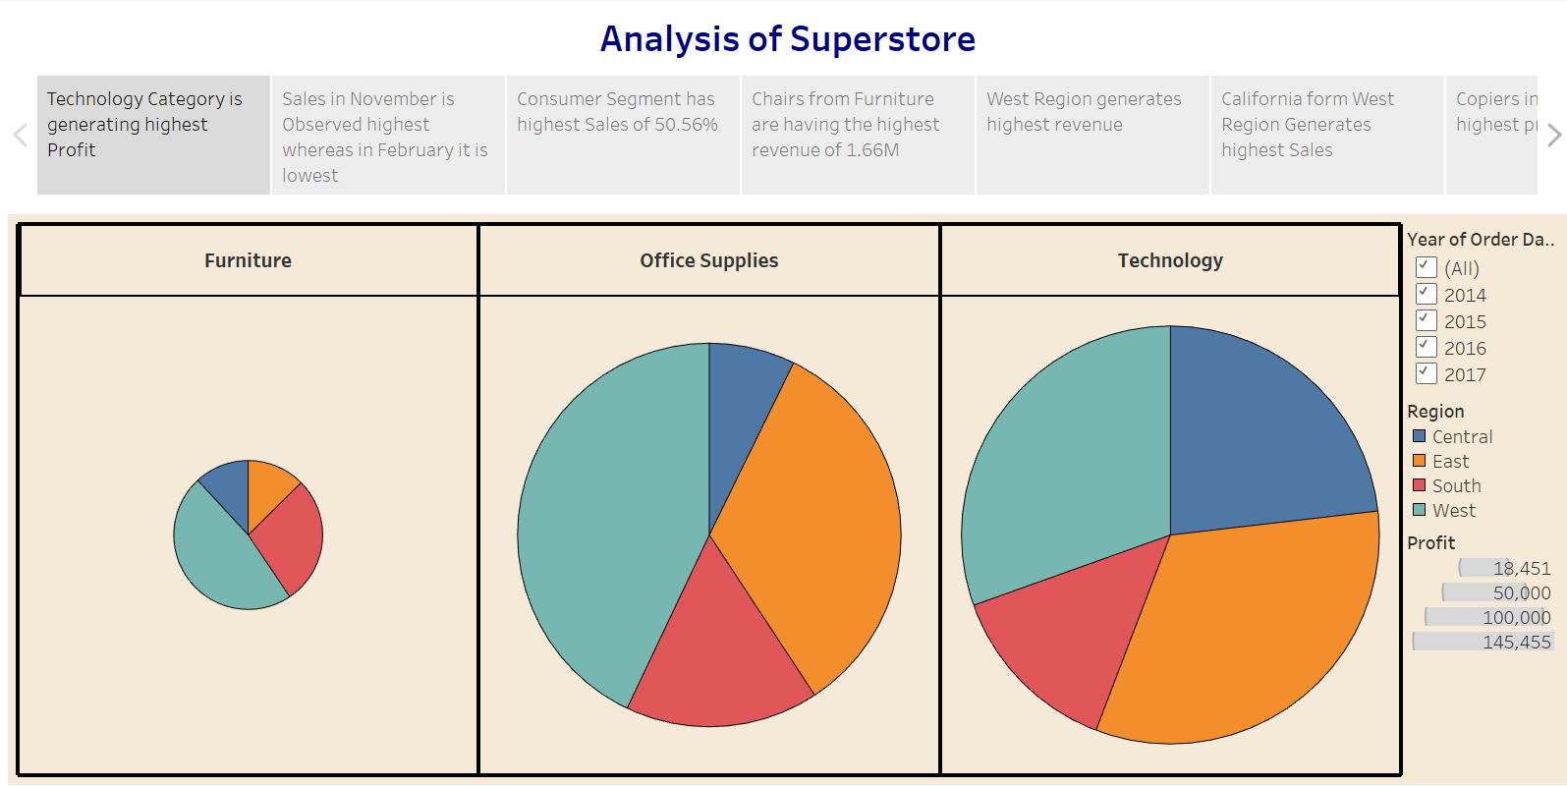

Observations:
- Technology Category Leads in Profit: The Technology category is generating the highest profit among all categories.
- Seasonal Sales Trend: Sales peak in November, while February sees the lowest sales, indicating a possible seasonal trend.
- Consumer Segment Dominates: The Consumer segment contributes to the highest percentage of sales, accounting for 50.56%.
- Top Revenue-Generating Product: Chairs from the Furniture category generate the highest revenue, totaling 1.66M.

Activity 2:
Publish Story on Tableau Public and Paste Public link below
https://public.tableau.com/views/SalesStory_17247663658720/Story1?:language=en-US&:sid=&:redirect=auth&:display_count=n&:origin=viz_share_link

EV Market Story – Story Points and Observations
The Tableau Story presents the EV market analysis as a sequence of story points. The visible story captions introduce the market overview, year-wise growth, vehicle-category share, battery technology and the overall growth message.
• Market overview: the first story caption describes the electric-vehicle market and states 3.42 million EV sales.
• Growth trend: the story caption refers to growth from 400,000 in 2021 to 832,000 in 2024.
• Vehicle category and technology: a story caption highlights a 44% SUV share and 2M+ NMC battery sales.
• Battery technology: another caption highlights NMC battery sales of 2M+ and describes it as preferred for long range.
• Market growth: the final visible caption states 142% growth from 2021 to 2025.

Story Screenshot Evidence
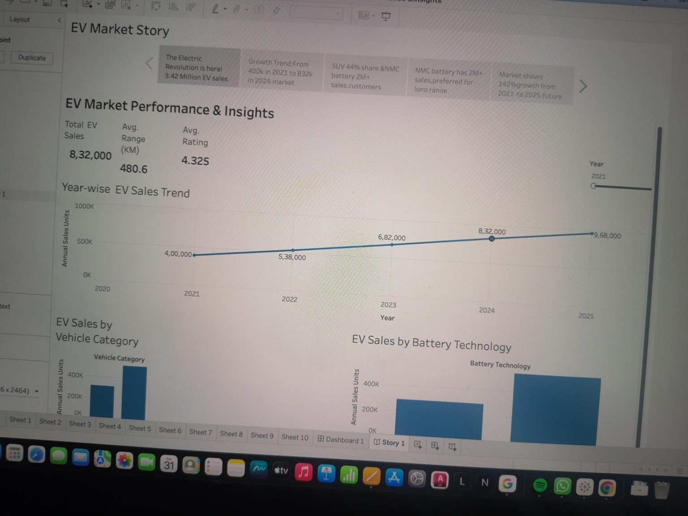

Observations from the Dashboard and Story
• The dashboard's KPI cards provide a quick overview of total EV sales, average driving range and average customer rating.
• The year-wise line chart shows a steady upward pattern from 2021 through 2025 in the displayed values.
• The SUV bar is higher than the Sedan bar in the visible vehicle-category comparison.
• The NMC bar is higher than the LFP bar in the battery-technology comparison.
• The country chart and map allow users to compare EV sales across geographic markets.
• The manufacturer pie chart shows the relative contribution of manufacturers included in the dataset.
• The scatter plot supports comparison of average vehicle price and customer rating.
Important consistency check: the Story's first caption says 3.42 million EV sales, while the dashboard KPI screenshot shows 832,000 total sales. The Story also refers to 832,000 in 2024 while the line chart screenshot labels 968,000 in 2025. Please reconcile these captions with the connected dataset and update the Story if necessary before final submission.

Activity 2 – Publish Story on Tableau Public
Published Tableau Public Story link:
https://public.tableau.com/app/profile/joha.khan/viz/EVMarketPerformanceInsights_17930988283380/Story1?publish=yes
Confirm that this link opens the Story1 view and that all story points are visible to a reviewer.

